Lab 4 Worksheet Sedimentary Rocks
Name ______ (-2 points if missing)
Date _______
Use your textbook, lab and lecture PowerPoints, and internet as needed to answer all questions in each of the 2 parts. Please explain everything in your own words.
Part 1
Rock name | Description of your personal sample: Include texture (as described in the ppt), composition, and any identifiable minerals, or explain why there are no identifiable minerals.
- Shale | Fine-grained clastic sedimentary rock composed of mud which is a mixture of clay minerals and the silt-sized particles. Contains calcite and quartz minerals.
- Calcareous Tufa | Sedimentary rock, composed of CaCO3 and is very porous.
- Sandstone | Composed of quartz sand minerals, Sedimentary rock, hard, very porous.
- Conglomerate | Smooth, Made of silica, iron oxide or calcite, sedimentary rock
- Limestone | Carbonate sedimentary rock, calcium carbonate composition, soluble to water and mild acid, hardness varies

Part 2
- How could you determine which cement is holding your sandstone together?
  - By considering the strength, durability and weather-resistant properties of the sandstone.
- Shale comes in many different colors. What color is your sample?
  - Yellow
- Based on the description of limestones in the lab ppt, what type of limestone is shown here?
  - 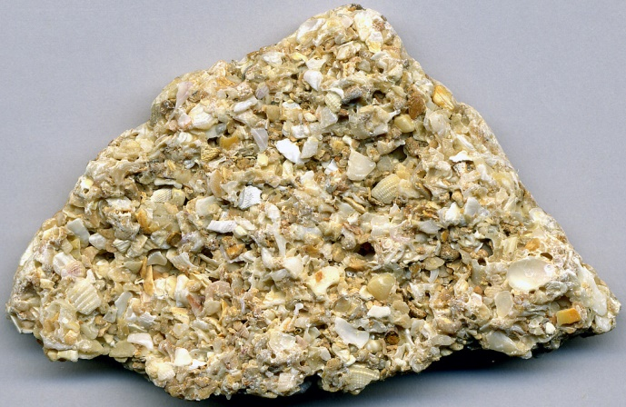
  - Shelly limestone
- Identify a test to quickly determine any kind of limestone.
  - Acid test
- Explain how the clastic rocks tell us about the distance from the sources of the grains.
  - If they are not too fine, you should be able to tell if they are well rounded.
- What is the difference between travertine and micrite?
  - Travertine; Terrestrial sedimentary rock, formed due to the precipitation of carbonate minerals from the ground solution together with the surface waters while Micrite is known to be limestone constituent formed by lime mud recrystallization.
- Identify at least 2 depositional environments for shale.
  - Ancient beach
  - Swamps.
- Where is a place near you in which future sandstone may be in the process of forming?
  - River.
- Explain the difference between grain rounding and sphericity.
  - Sphericity refers to the spherical nature of an object while grain rounding occurs when angular corners of rock fragments are removed from a piece of sediment due to abrasion during transport.
- Classify the following sedimentary rocks as either clastic, chemical, or biogenic.
Gypsum | Chemical
Coal | Biogenic
Breccia | Chemical
Rock salt | Chemical
Coquina | Biogenic
Sandstone | Clastic

- Identify a place on earth where rock salt is forming right now.
  - Atlantic Ocean.
- Would a conglomerate be well sorted or poorly sorted, and why?
  - Well sorted: contain finer grained sediment.

- What type of rock is pictured here?
  - 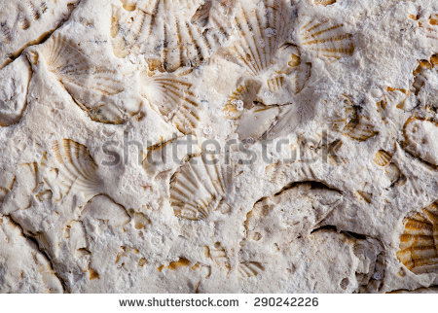
  - Clastic rock
- Describe the rock in the image in terms of rounding and sorting
  - 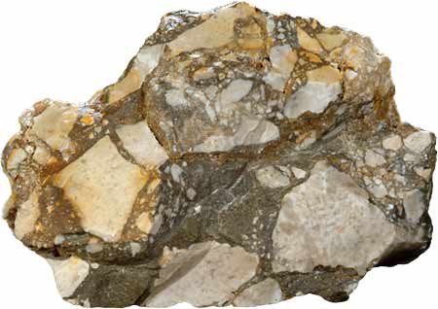
  - Poorly sorted
More rounded
- What future rock would be developing in a V-shaped mountain valley?
  - Regolith.

